When I think of the difference between radio buttons and checkboxes, I like to think of music. Specifically, I think of the relationship between the types of music I like, and my favorite music. I like several types of music, but I can only have one favorite type. You see, the word favorite is an exclusionary word which means there can only be one. It is like best, or most, there is only one. By thinking of that, I think of how check boxes can describe the many types of music I like, while a button group of radio buttons can be used to select the favorite type of music. To illustrate this I wrote a short program to choose the genres of music you like, and your favorite genre of music. Once you have made your choices, or made none at all, simply click the “click” button and a message pops up to recap what you have chosen:

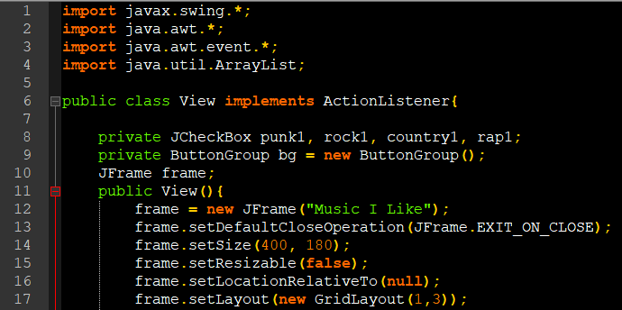

First I import all of the necessary classes and packages, then I define the View class which implements ActionListener so that it can take the GUI input and process it. Then I define the variables which will be needed in multiple methods of the class. Note that I must define the checkboxes here as they will be queried directly from the actionPerformed() method, but I do not have to define the radio buttons. The reason is that I define the button group here so that it can be queried from the actionPerformed() method, then I place the radio buttons inside it. After that I set up a JFrame to hold all of the components. After that I define the first of the three objects; the favoritePanel JPanel:

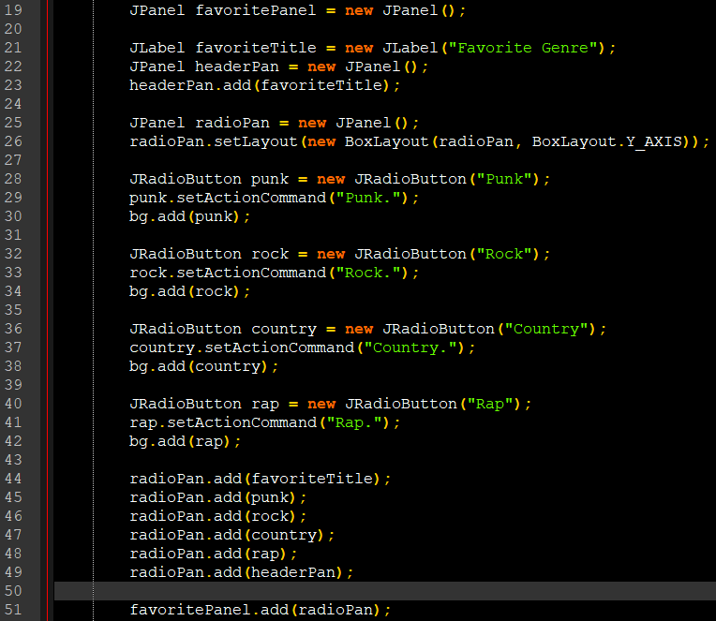

This is the panel in which I group all of the radio buttons and a header JLabel to describe them. I realize this is not an exhaustive list of musical genres, but I didn’t want to go overboard, haha. Finally, I add all of the components to their respective panels, and then to the favoritePanel. After this, I define the second panel, likeWrapper. I do it this way to make sure the contents of each panel are centered in their respective panels. By using the default (flow) layout for the wrapper, I save some code in centering all the text on the following panel:

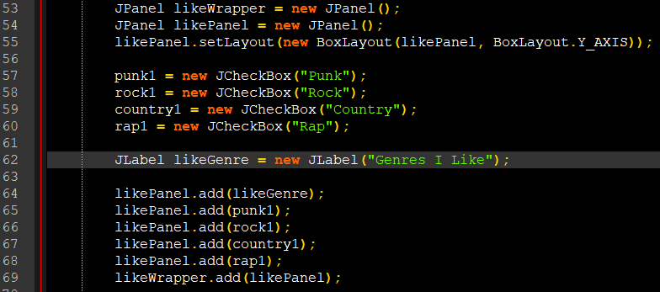

After this panel is set, I create the button, and add all of the components to the frame. Finally, I set the frame to visible:

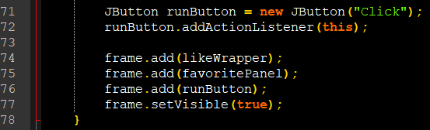

The last thing to do is implement ActionListener by creating the actionPerformed(ActionEvent e) method. This is my implementation:

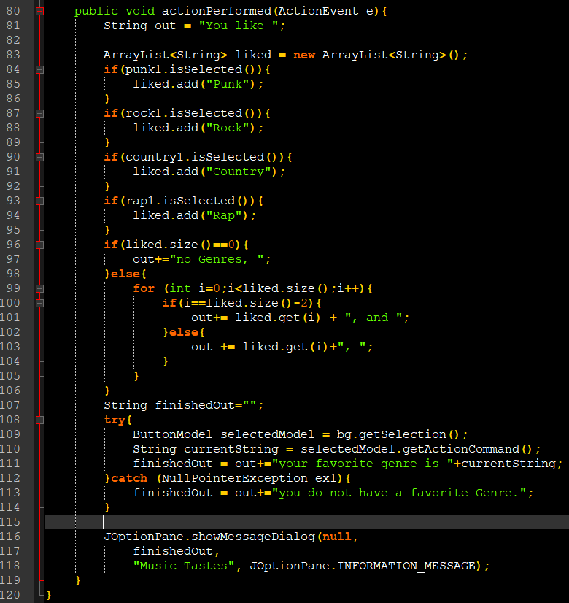

For this method I query each JCheckBox, and if it is checked I add its actionEvent (defined above) to the ArrayList<String> liked to later add to the String output. After that, I try to get the selected JRadioButton from the button group, or set the appropriate response. Finally, I display the checked genres and the favorite genre in a JOptionPane. Below is a screenshot of the output with all boxes checked and punk as the favorite genre:

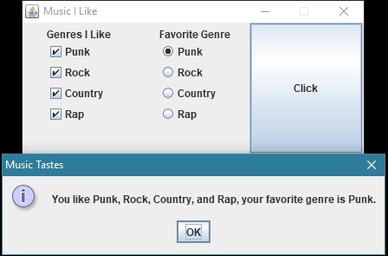

I have attached the code to this post, and it can be found, along with my other code at my github at: <https://github.com/joshc1224/javaHelpers> under the folder Favorite Music Program.